In-Person Meeting at Fairfax County Health Department

March 7, 2019 12:00 p.m.

1. Attendance: The following persons were present: Julia Balsley (late), Nicole Biala Gragasin, Amanda Losardo on-phone, Allison Olguin, Kristen Pybus and Austyn Ries
2. Business:
3. Calendar Planning:

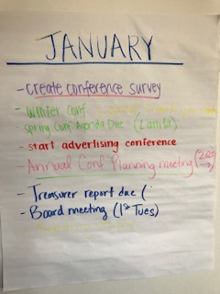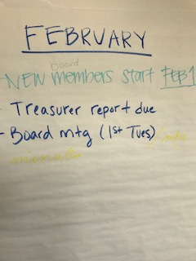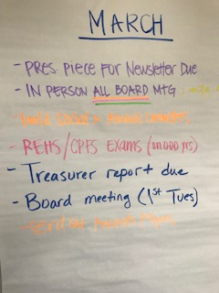

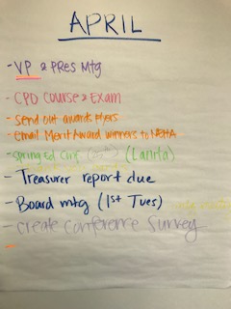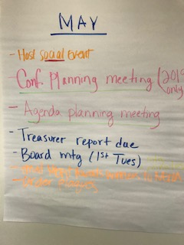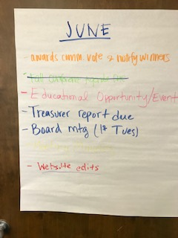

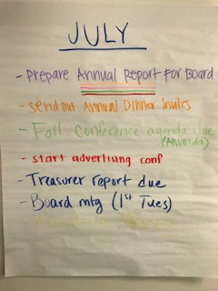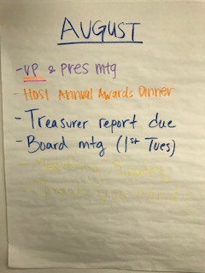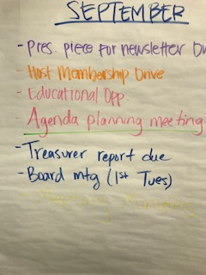

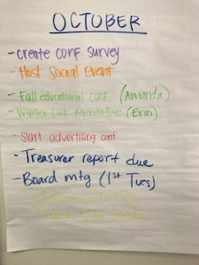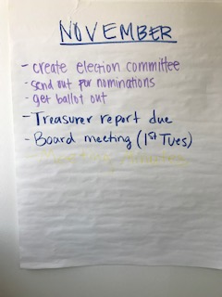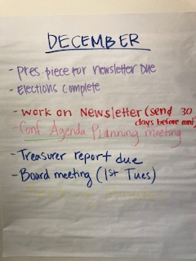

1. Conference Planning: If Kristen emails a Representative, they must respond within three days or she will pull the conference from them and give to the VP of Programs. We would like to offer a happy hour after every conference and have at least two board members in attendance.
2. Board Meeting Conference Calls: First Tuesday of every month at 9:00 a.m. for one hour
3. Membership Platform: *Wild Apricot*, beginning with a free 30-day trial, board voted and approved to initiate to handle membership list and renewals
4. VP of Membership/March items to do: build social & awards committees, survey membership, update business card and order new ones for the organization
5. Director of Communications: Austyn will be taking over completely from Chuti starting April 1st. All emails to members should come from her. met over the weekend to discuss the position, shared passwords; for Austyn will eventually take over for Chuti. Austyn may create an assistant DOC position. Create a new Gmail account email for business card
6. President: will be updating the website. The board voted and approved Kristen to attend the NEHA AEC this summer and for her to purchase a NCAEHA tablecloth. Kristen will email Lanita today to confirm DC Health Spring Conference date and location by Tuesday. If she can’t confirm we will move to having it in MD. Let Kristen know if you want to be on a committee for the FDA Central Region Retail Food Protection Seminar.

Next Meeting: Conference Call April 2nd 9 a.m.; but since has changed to April 1st 9 a.m.

Adjournment: 2:55 p.m.

Minutes submitted by Julia Balsley